**Blockchain Technology Lab**

**Lab – 7**

**Aim : Create a Hello World Smart Contract in Remix -IDE**

**Steps:**

**1.** Open the remix-ide in your browser by typing: <https://remix.ethereum.org/>. You will be presented with following screen:

**2.** Click new and create a new workspace file called helloworld.sol

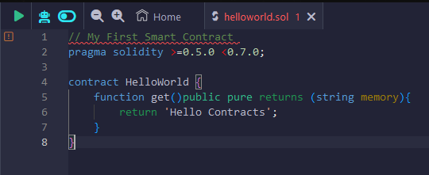

**3.** Go to Solidity Compiler and click on compile.

**4.** After compilation, click on “deploy and run transactions” and click on deploy

**5.** After the deployment, go to “deployed contracts” and click on get.

